Notes

Network Theory.

.

Learning Objectives
Students will learn basic concepts of different type of signals and transients response.

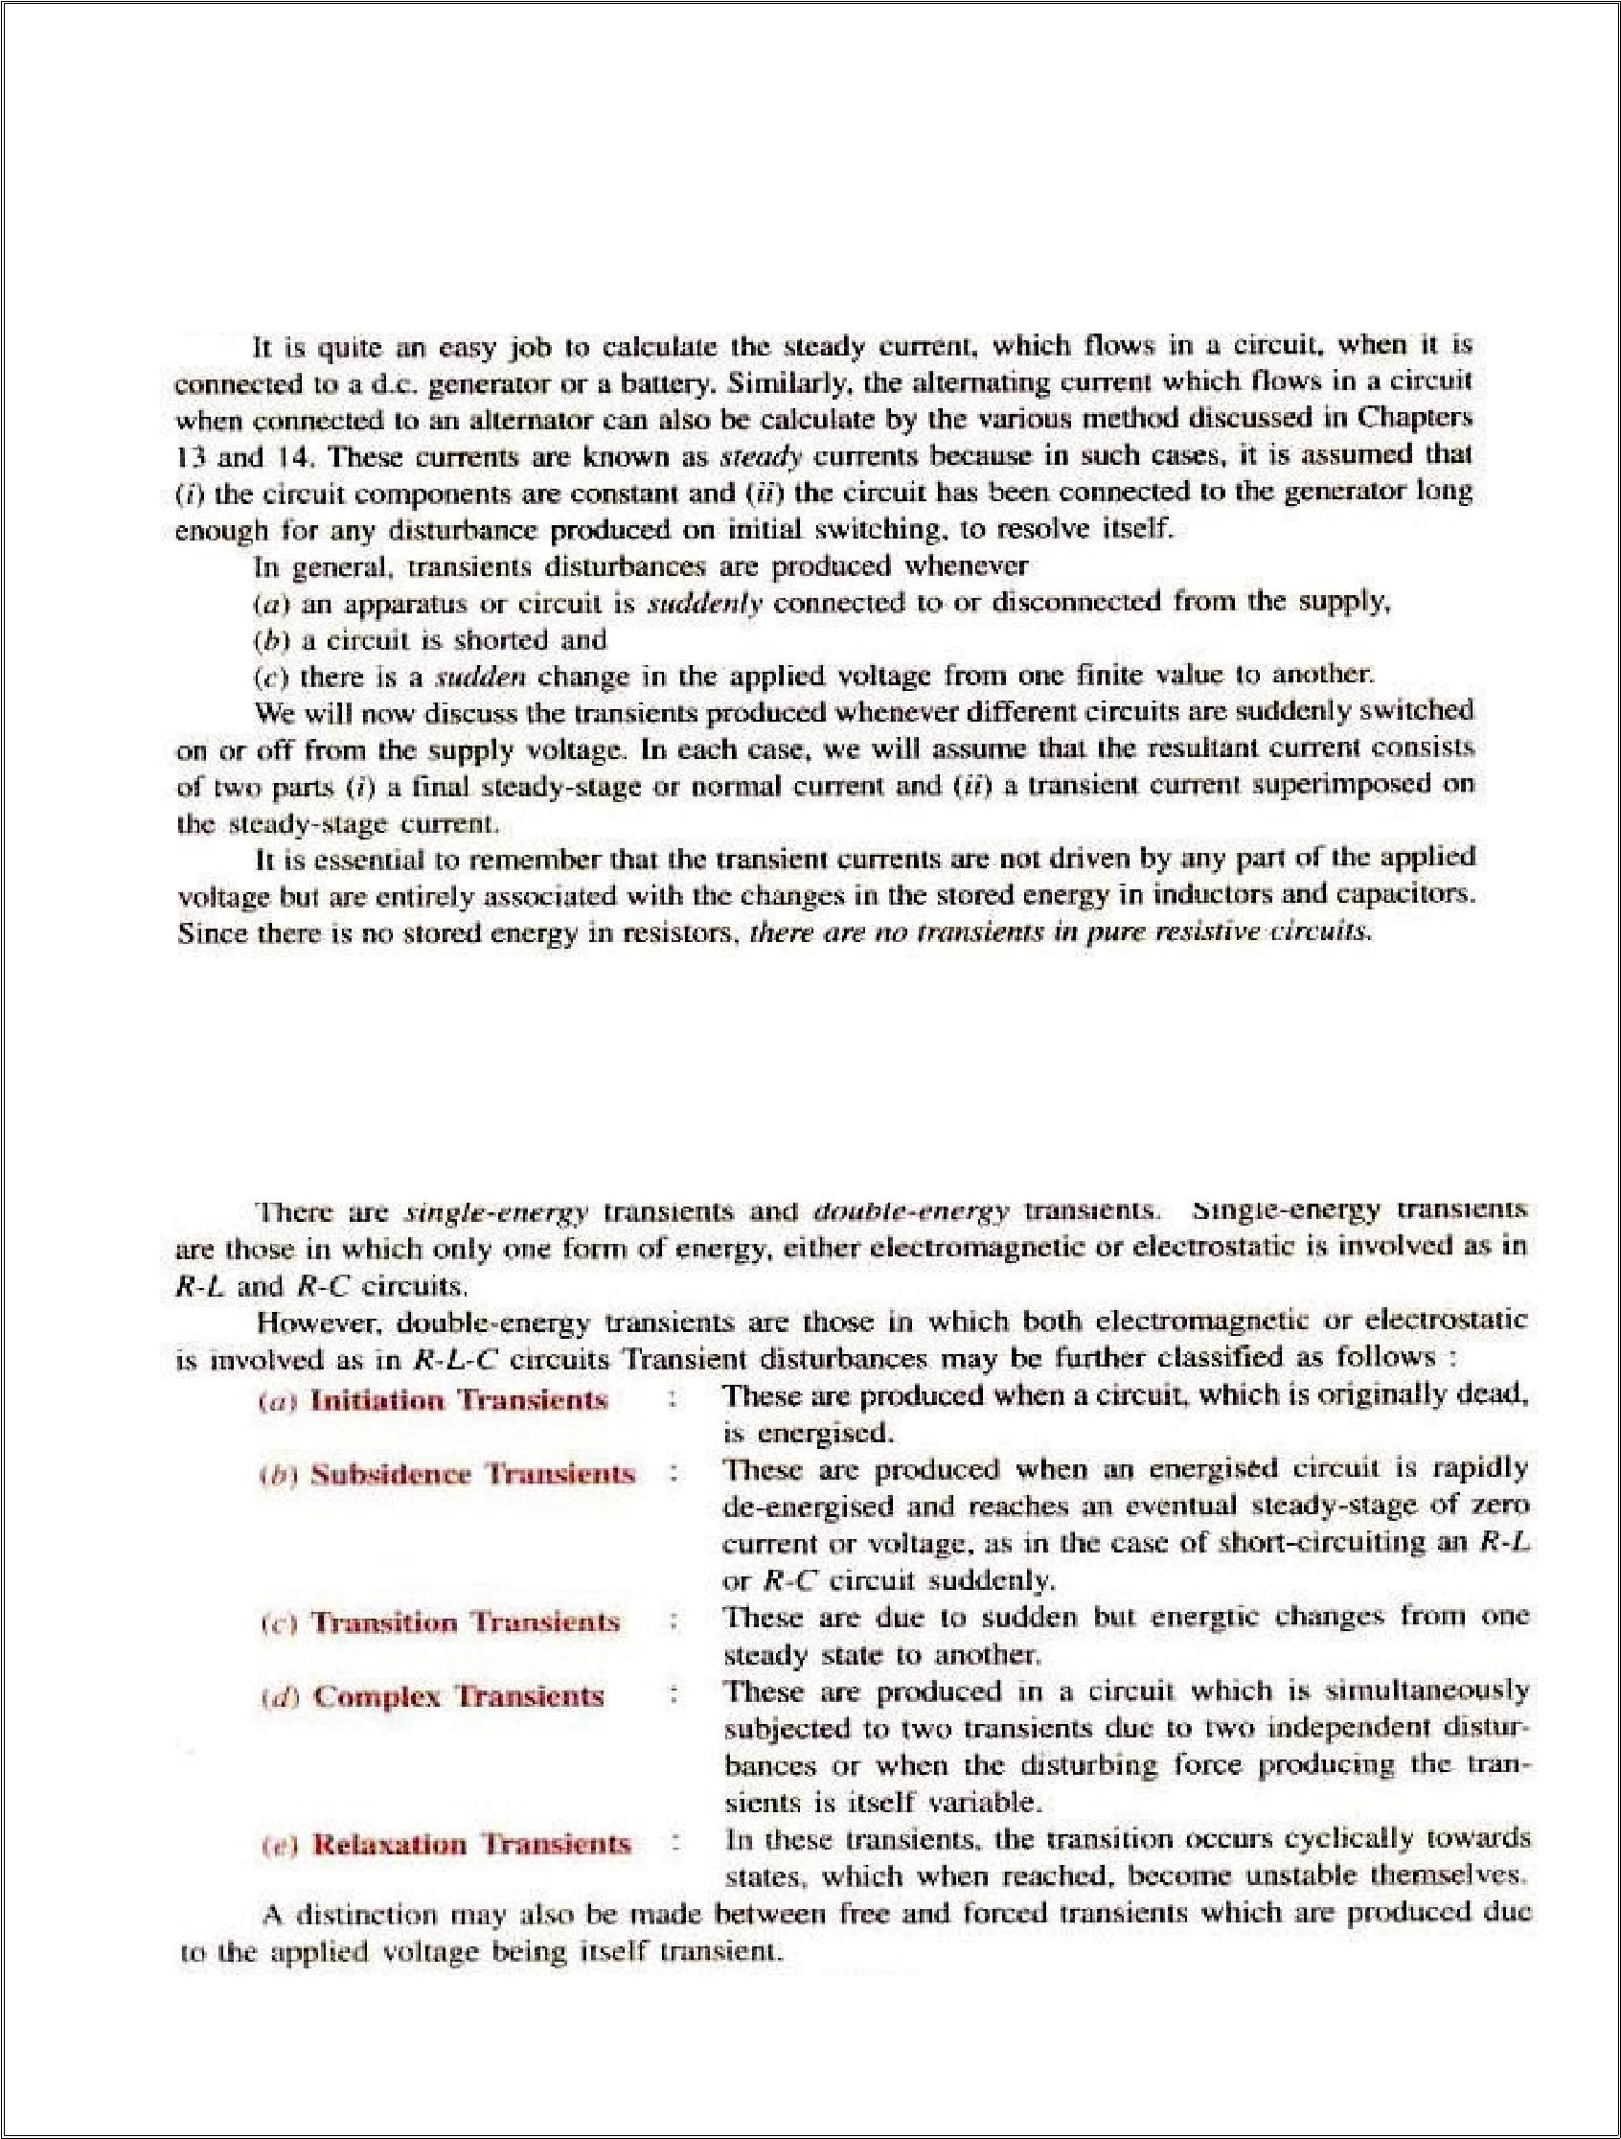
2

UNIT-2

TRANSIENTS

INTRODUCTION:-

TYPES OF TRANSIENTS-

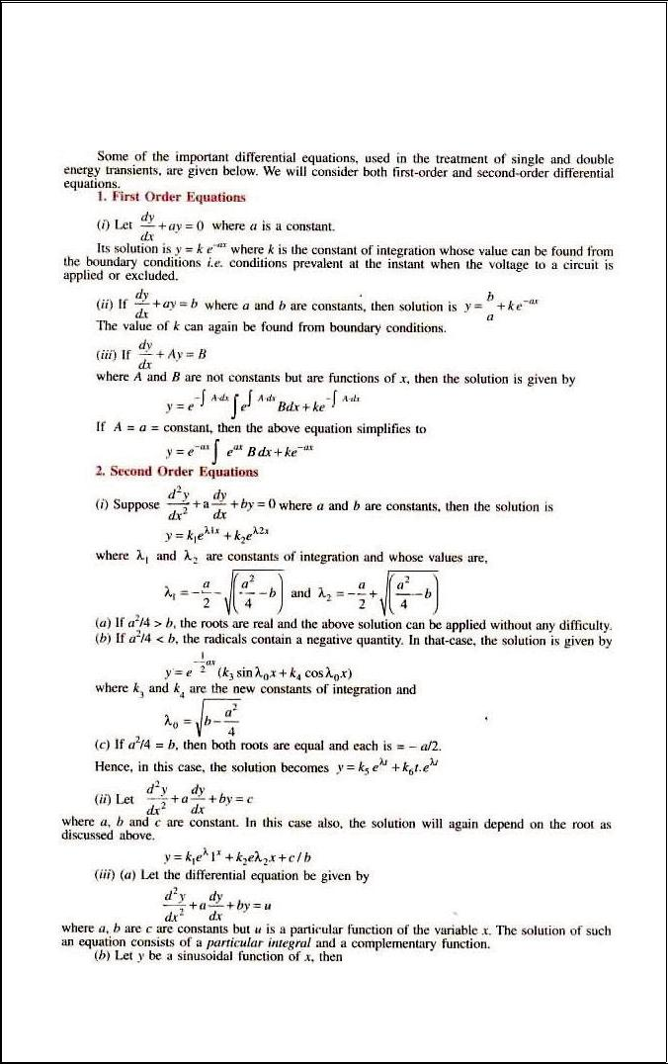
3

IMPORTANT EQUATIONS:-

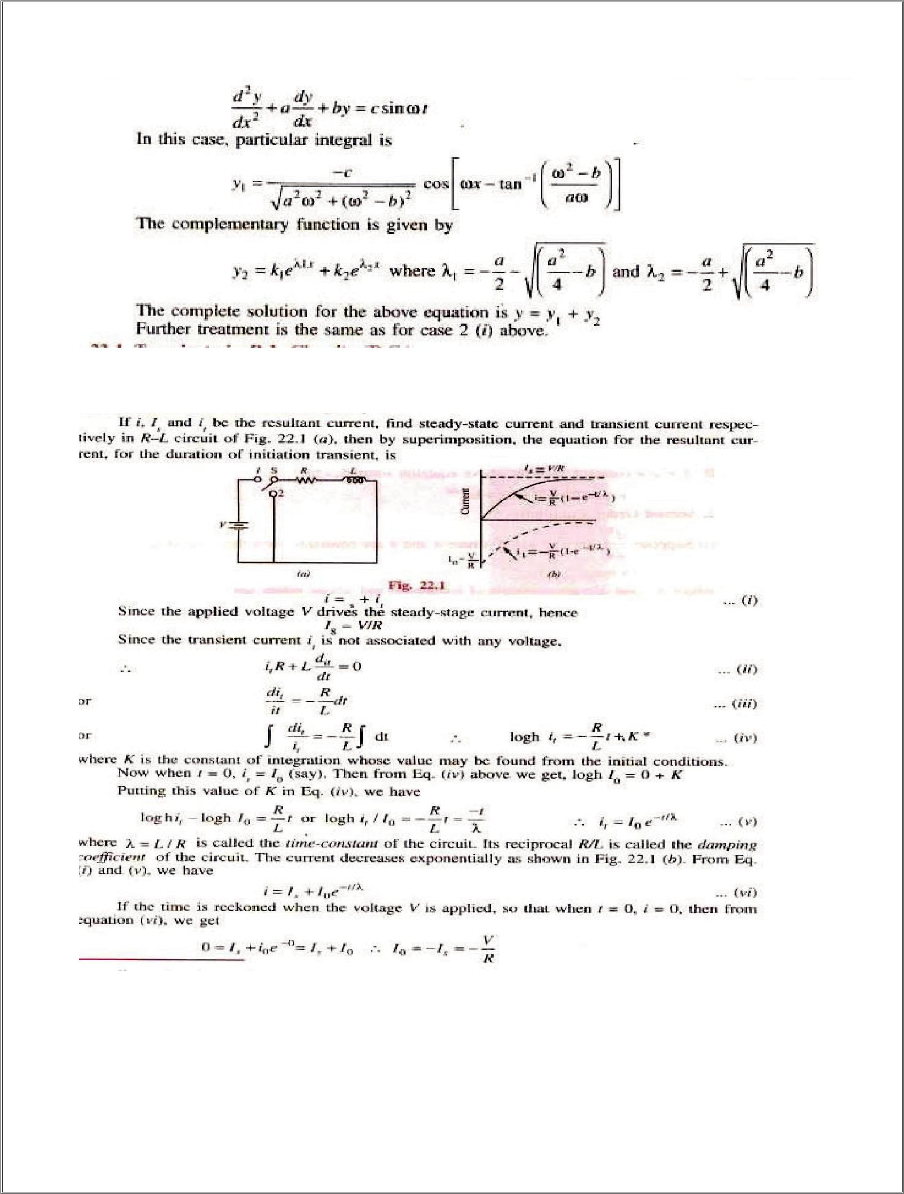
4

TRANSIENTS IN RL CIRCUITS(DC):-

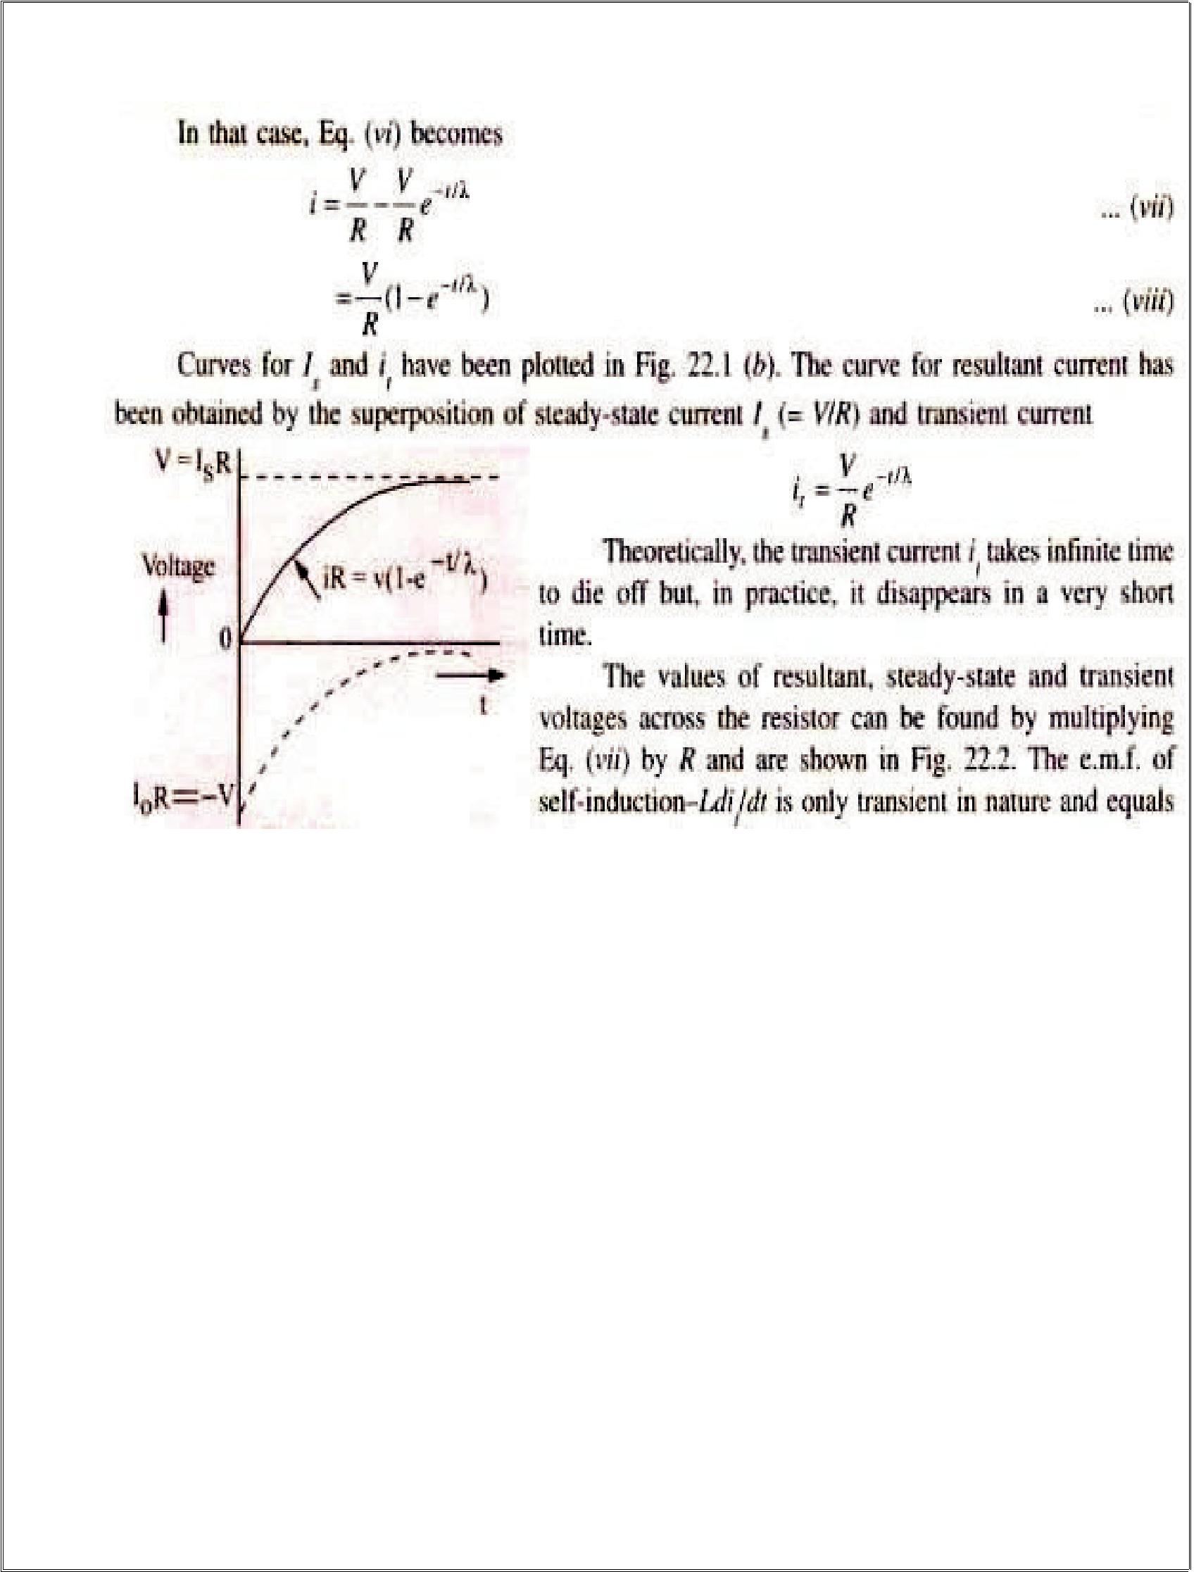
5
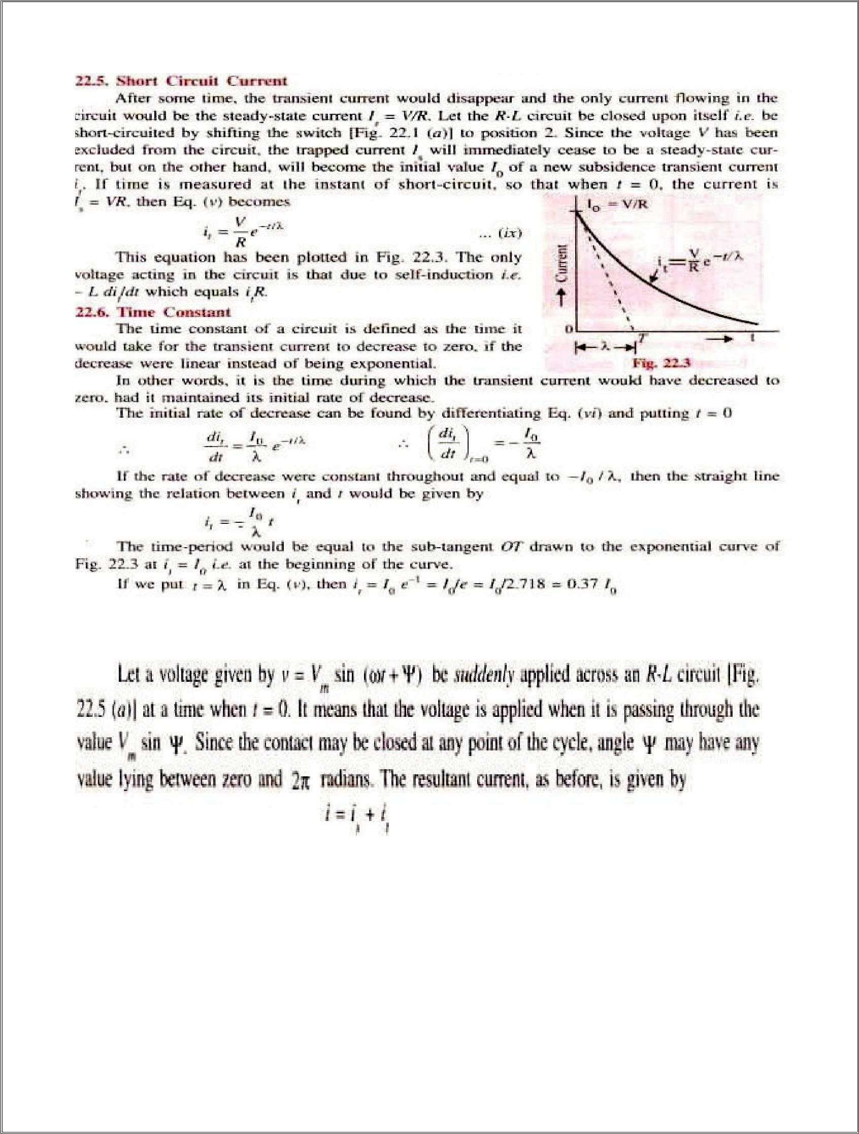
6

TRANSIENTS IN RL CIRCUITS(AC):-

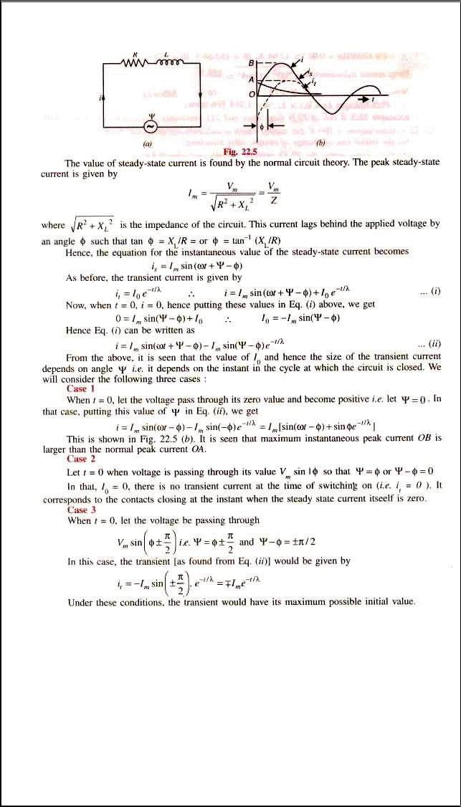
7

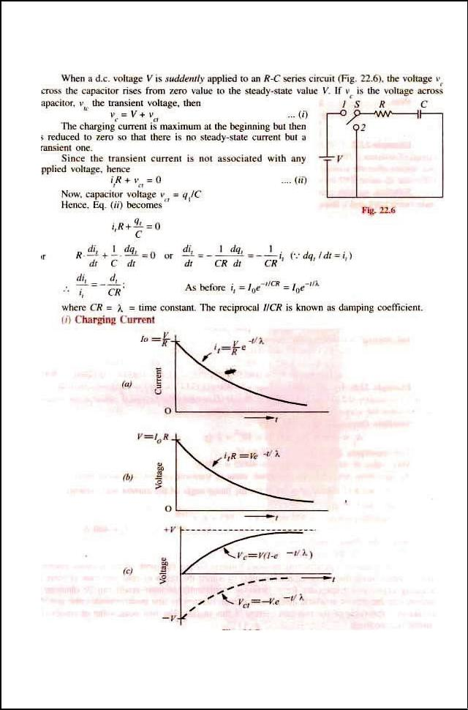
8

TRANSIENTS IN RC CIRCUITS(dc):-

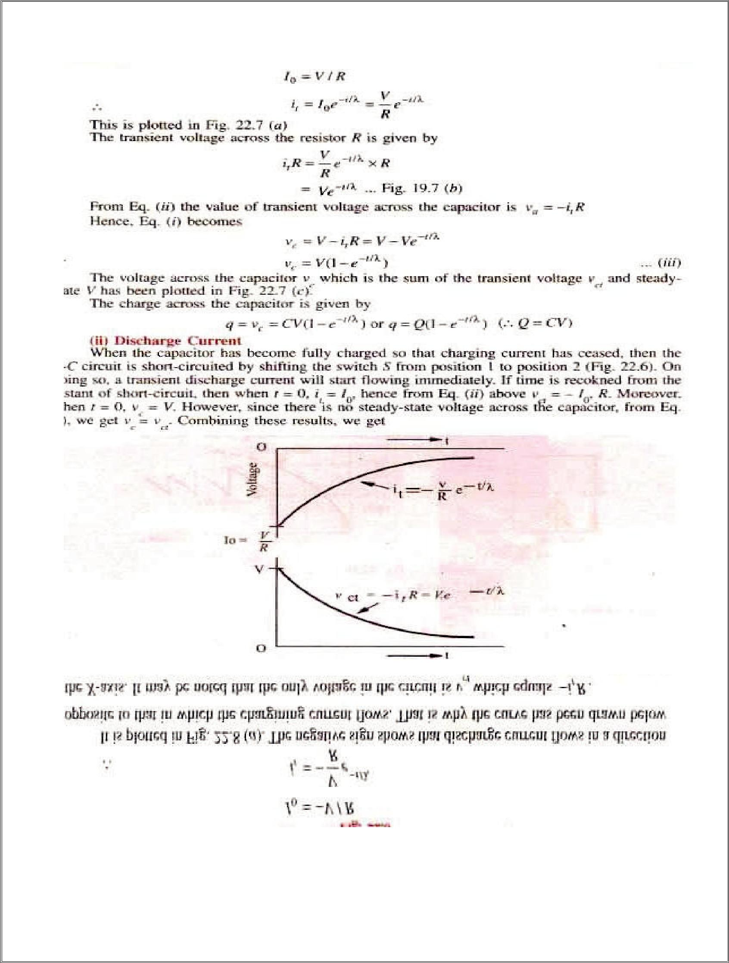
9

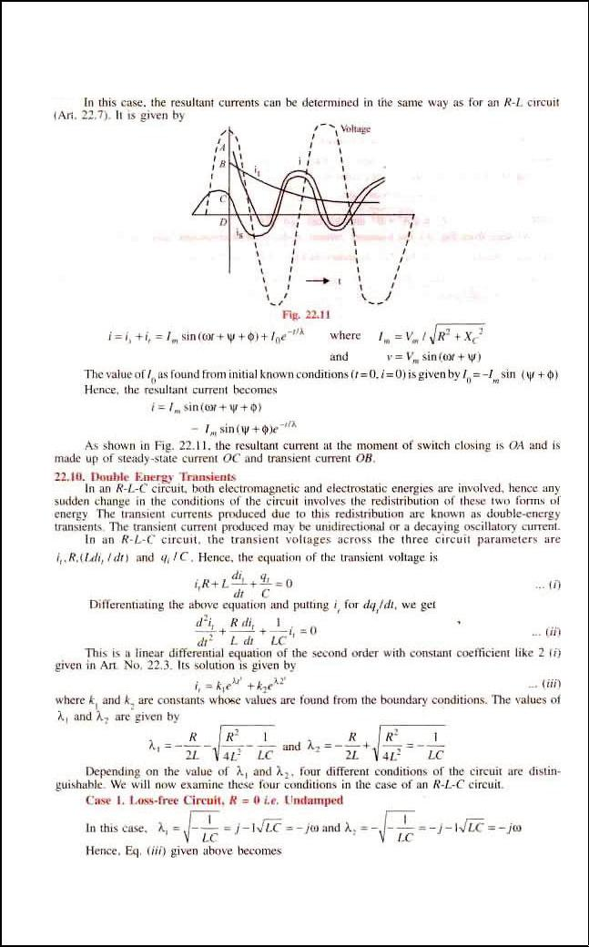
10

TRANSIENTS IN RC CIRCUITS(ac):-

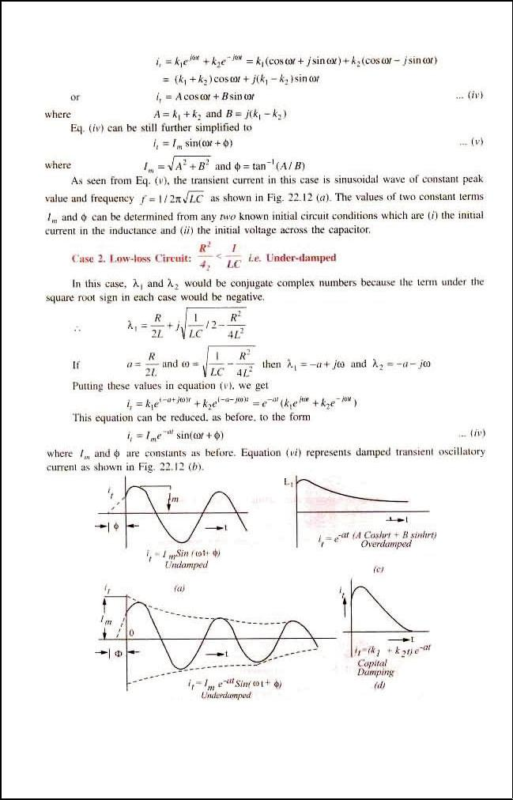
11

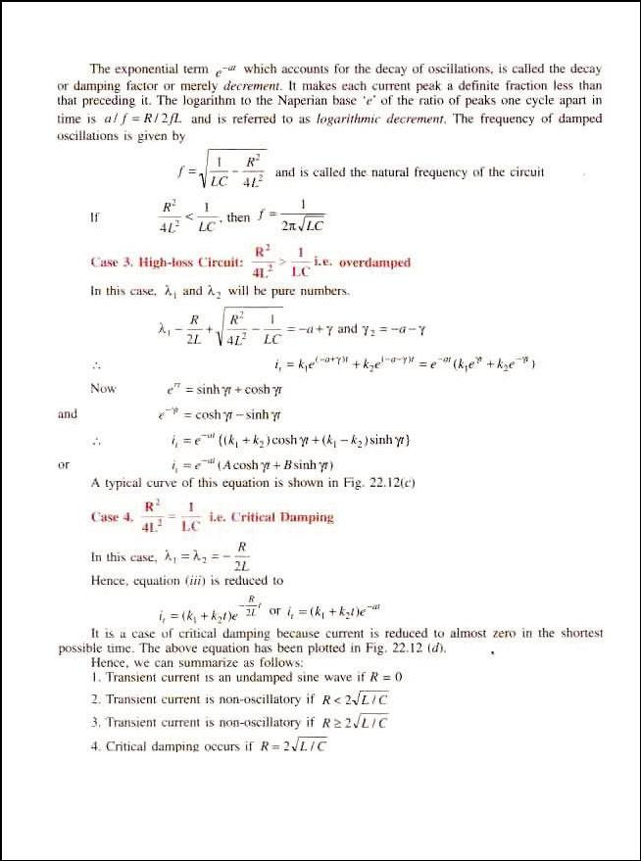
12

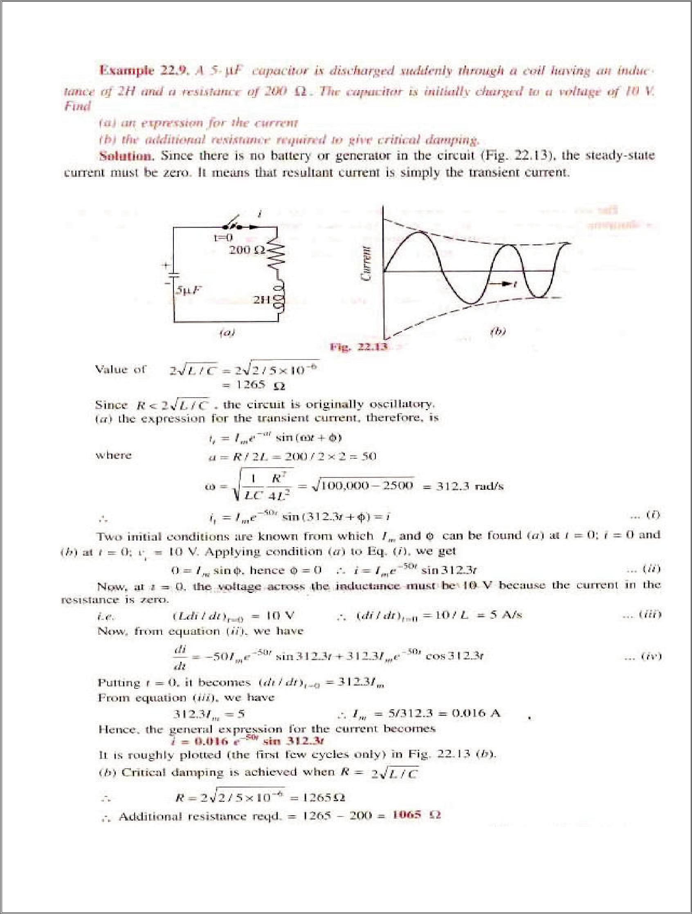
13

Beyond syllabus
Steps, Impulses and Ramps

The unit step function u[n] is defined as:

u[n] = 0, n < 0

u[n] = 1, n ≥ 0
This signal plays a valuable role in the analysis and testing of digital signals and processors.
Another basic signal which is even more important than the unit step, is the unit impulse function δ[n], and is defined as:
δ[n] = 0, n ≠ 0
δ[n] = 1, n = 0

the unit step function the unit impulse function

One further signal is the digital ramp which rises or falls linearly with the variable n. The unit ramp function r[n] is defined as:
r[n] = n u[n]

The unit ramp function

Since u[n] is zero for n<0, so is the ramp function

The Unit Impulse Response
The unit impulse was described above as:
δ[n] = 0, n ≠ 0
δ[n] = 1, n = 0
This is also sometimes known as the Kronecker delta function

n |  | -2 |  | -1 |  | 0 |  | 1 |  | 2 |  | 3 |  | 4 |  | 5 |  | 6
δ[n] | 0 |  | 0 |  | 0 |  | 1 |  | 0 | 0 | 0 |  | 0 |  | 0 |  | 0 |  | 0
δ[n-2] | 0 |  | 0 |  | 0 |  | 0 |  | 0 | 1 | 0 |  | 0 |  | 0 |  | 0 |  | 0

Shifted impulse sequence, δ[n – 2]

A shifted impulse such as δ[n – 2] is non-zero when its argument is zero, i.e. n – 2 = 0, or equivalently n = 2.
2
The third row of table 1 gives the values of the shifted impulse δ[n – 2] and Figure shows a plot of the sequence.
Now consider the following signal:

x[n] = 2δ[n ] + 4δ[n – 1] + 6δ[n – 2] + 4δ[n – 3] + 2δ[n – 4]

shows the individual sequences and their sum
n |  |  | -2 |  |  | -1 |  |  | 0 |  |  | 1 |  |  | 2 |  |  | 3 |  |  | 4 |  |  | 5 |  |  | 6
2δ[n] | 0 |  |  | 0 |  |  | 0 |  |  | 2 |  |  | 0 |  | 0 |  | 0 |  |  | 0 |  |  | 0 |  |  | 0 |  |  | 0
4δ[n-1] | 0 |  |  | 0 |  |  | 0 |  |  | 0 |  |  | 4 |  | 0 |  | 0 |  |  | 0 |  |  | 0 |  |  | 0 |  |  | 0
6δ[n-2] |  | 0 |  |  | 0 |  |  | 0 |  |  | 0 |  |  | 6 |  | 0 |  |  | 0 |  |  | 0 |  |  | 0 |  |  | 0
4δ[n-3] | 0 |  |  | 0 |  |  | 0 |  |  | 0 |  |  | 0 |  | 0 |  | 4 |  |  | 0 |  |  | 0 |  |  | 0 |  |  | 0
2δ[n-4] | 0 |  |  | 0 |  |  | 0 |  |  | 0 |  |  | 0 |  | 0 |  | 0 |  |  | 2 |  |  | 0 |  |  | 0 |  |  | 0
x[n] | 0 |  |  | 0 |  |  | 0 |  |  | 2 |  |  | 4 |  | 6 |  | 4 |  |  | 2 |  |  | 0 |  |  | 0 |  |  | 0

Hence any sequence can be represented by the equation:
Σ−=kknkxnx][][][δ
= + x[-1]δ[n + 1] + x[0]δ[n] + x[1]δ[n - 1] + x[2]δ[n - 2] +…….
When the input to an FIR filter is a unit impulse sequence, x[n] = δ[n], the output is known as the unit impulse response, which is normally donated as h[n].
Substituting x[n] = δ[n] gives the output y[n] = h[n].

